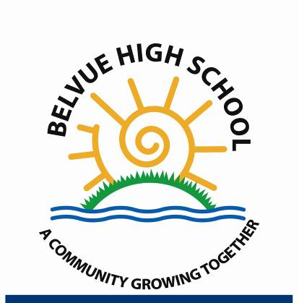
Headteacher: Ms. Shelagh O'Shea

head@belvue.ealing.sch.uk

Rowdell Rd
Northolt
Middx
UB5 6AG
Tel: 0208 845 5766

30th March 2023

Dear Parent/Carers,

Re: Pupil Premium and Free School Meals

If your child is eligible for ‘free school meals’ and you register them for this, we will receive extra funding called ‘pupil premium’. We use this extra money to improve the educational provision and resources at the school.

What is pupil premium funding?

Pupil premium funding from the government is given to schools to help pupils reach their full potential, regardless of their background or financial situation. It’s provided for pupils who:

- Are registered for free school meals
- Have been registered for free school meals at any point in the past 6 years
- Are, or have been, in care
- Have parents in the armed forces
At Belvue School, we get an extra £985 for every eligible pupil who is registered for free school meals. This extra money could make a real difference to the quality of education we offer.

Is my child eligible for free school meals?

Your child might be eligible if you access:

- Income Support
- Income-based Jobseeker’s Allowance or Income-related Employment and Support Allowance
- Support under part VI of the Immigration and Asylum Act 1999
- The guaranteed element of Pension Credit
- Child Tax Credit (provided you’re not also entitled to Working Tax Credit and have an annual gross income of no more than £16,190)
- Working Tax Credit run-on
- Universal Credit, provided you have an annual net earned income not exceeding £7,400 (£616.67 per month)
Your child might also be eligible if you’re in a household with no recourse to public funds (NRPF), subject to a maximum income threshold. This is for children of:
- Zambrano and Chen carers (non-EEA nationals caring for a British citizen residing in the UK)
- British National (Overseas) passport holders
- Spousal visa, work visa, or student visa holders
- Those with no immigration status
- Families with a right to remain in the UK under Article 8 of the European Convention of Human Rights
- Families receiving support under Section 17 of the Children Act 1989 who are subject to a no recourse to public funds restriction
- Certain failed asylum seekers supported under Section 4 of the Immigration and Asylum Act 1999

Does my child have to eat the free school meals?

No. Pupils who are registered for free school meals don’t have to eat them. If you’re eligible but you want your child to have packed lunches you should still register because the school will receive the funding which can support your child in other ways.

How do I register?

If you are eligible for free school meals or require further information on this please click on the link: Free School Meals

Or please contact Pupil Support Services at Ealing by calling: 020 8825 5566 or Email Pupilsupport@ealing.gov.uk

More information

For more information about pupil premium go to our website, which contains details of how the pupil premium has been spent in the past academic year and how it will be spent this year.

If you have any questions or specific concerns, please contact the school office.

Yours sincerely,

Shelagh O Shea
Headteacher

